Website Planning Document
Site Name: Weekend Soccer Pickup Game
Reason for Site Name: The name Weekend Soccer Pickup Game was chosen because it clearly describes the purpose of the website. It lets users immediately know that the site is about informal soccer games held on weekends and is designed for community members looking to participate in pickup-style soccer matches.
Purpose for the site: The purpose of the Weekend Soccer Pickup Game website is to provide a central platform where community members can find information about weekend soccer pickup games. The site will share game schedules, locations, and times, as well as allow players to sign up to participate in upcoming games.
Scenarios:
Scenario #1: Game Time
Question: What time does the Weekend Soccer Pickup Game start?
Answer: The game time will be listed on the Game Details page so players can plan their weekend schedule.
Scenario #2: Game Location
Question: Where will the Weekend Soccer Pickup Games be played?
Answer: The game location will be provided on the Game Details page, including the name of the field.
Color Scheme
Primary Color
Baltic Blue (#065A82) – Used for headers, navigation background, and primary buttons to create a sporty and energetic feel
Secondary Color
White (#FFFFFF) – Used for the page background and main content areas to ensure readability and contrast against the primary color
Typography
Font Selected: Lato
Usage:
- Heading (h1, h2, h3): Lato, weight 400, for a modern and readable look.
- Body Test (paragraphs, lists): Lato, weight 100 – 400, to maintain readability and consistency across all pages.
All pages of the website, including Home Game Details, About, Sign Up, and confirmation, uses this font to ensure consistency
Wireframes
Mobile View
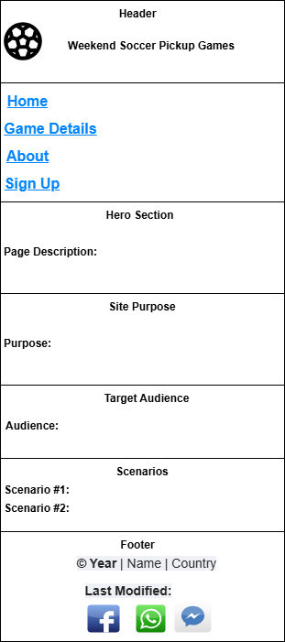
Desktop View
